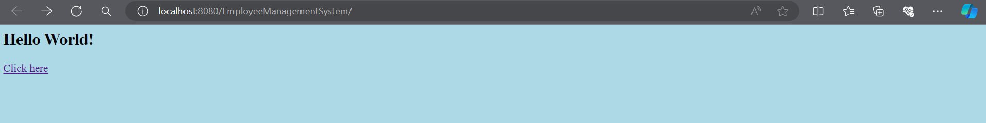**Home page :**

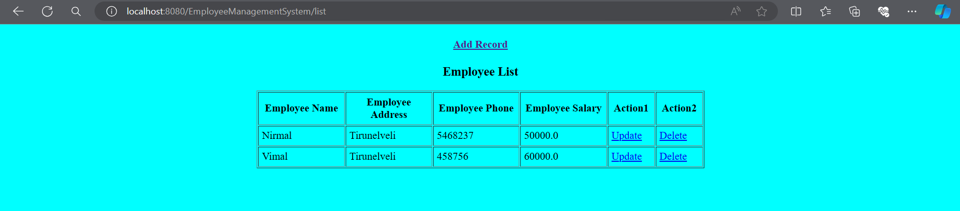**Employee List :**

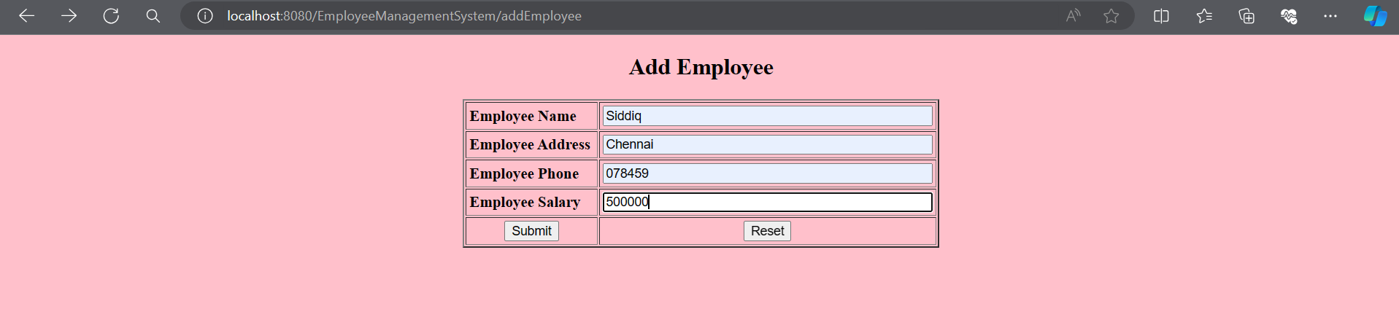**Add Employee :**

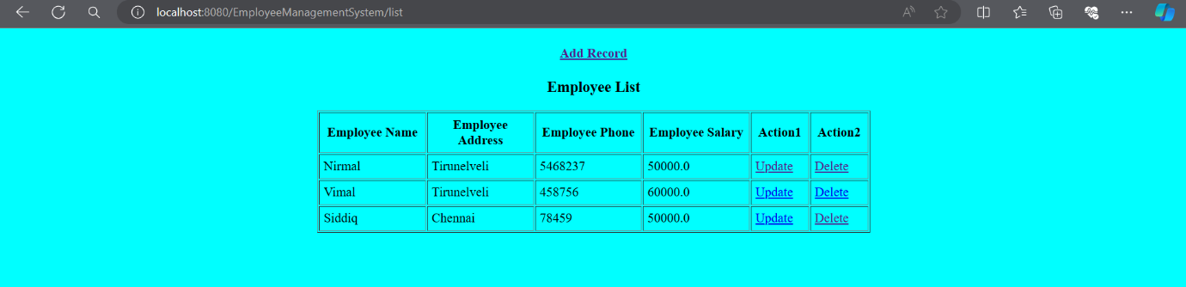**Updated List :**

**Clicking on Update :**

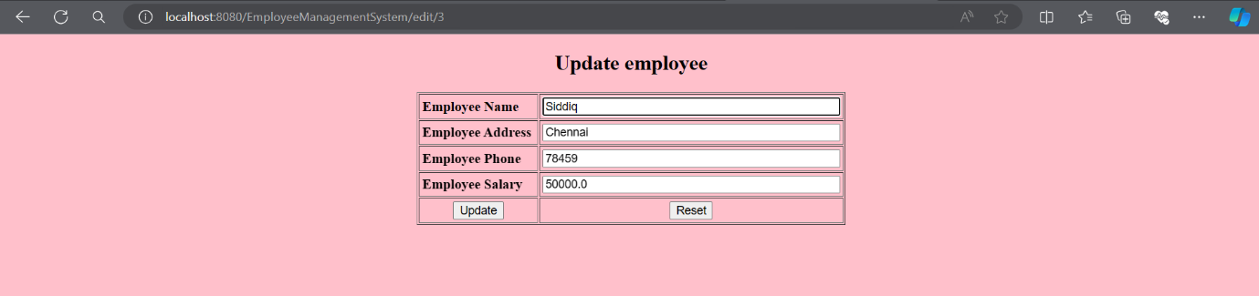**Updating data (**name**) :**

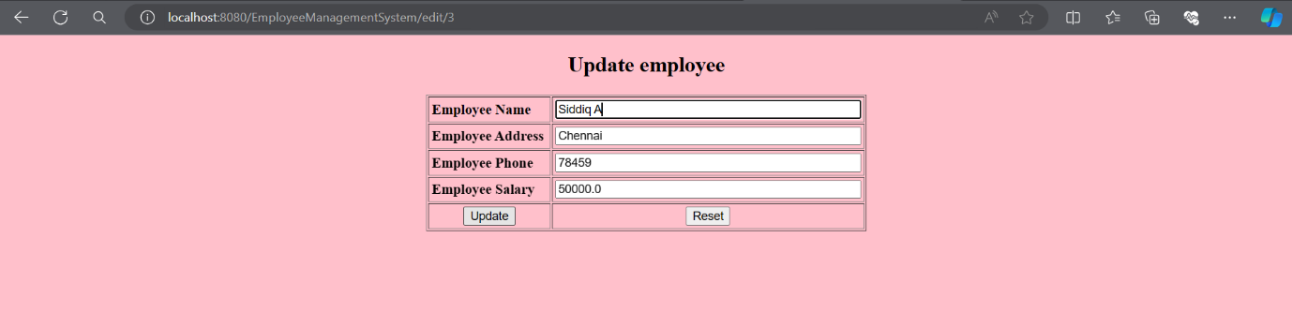

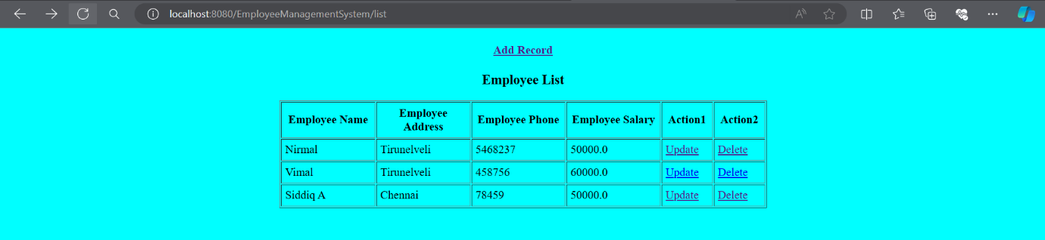**Updated List :**

**Delete Operation:**

